# Software Requirements Specification

# for

# <Housekeeping networking site >

Version 1.0 approved

Prepared by <Nizampatnam Mounish

Sravan Rahul Reddy

Kurapati Sarayu>

<Self organization>

<date 30 August, 2018>

Table of Contents

Table of Contents ii

Revision History ii

1. Introduction 1

1.1 Purpose 1

1.2 Document Conventions 1

1.3 Intended Audience and Reading Suggestions 1

1.4 Product Scope 1

1.5 References 1

2. Overall Description 1

2.1 Product Perspective 1

2.2 Product Functions 2

2.3 User Classes and Characteristics 2

2.4 Operating Environment 2

2.5 Design and Implementation Constraints 2

2.6 User Documentation 2

2.7 Assumptions and Dependencies 3

3. External Interface Requirements 3

3.1 User Interfaces 3

3.2 Hardware Interfaces 3

3.3 Software Interfaces 3

3.4 Communications Interfaces 3

4. System Features 4

4.1.Room Cleaning 4

4.2.Laundry Services 5

4.3.Create Profile………………………………………………………………………………5

Usecase Diagram………………………………………………………………………............6

4.4.Update Profile……………………………………………………………………………...7

4.5.Register…………………………………………………………………………………….8

4.6.Job Search………………………………………………………………………………….9

4.7.Give feedback……………………………………………………………………………...9

4.8.Handle visit care applications……………………………………………………………10

4.9.Post Job vacancies………………………………………………………………………11

4.10.Allot maid timings………………………………………………………………………12

4.11.Handle Feedback………………………………………………………………………..12

4.12.Contact for visit care…………………………………………………………………….13

4.13.Login…………………………………………………………………………………….14

4.14.Authentication…………………………………………………………………………..14

5. Other Nonfunctional Requirements 15

5.1 Performance Requirements 15

5.2 Security Requirements 15

5.3 Software Quality Attributes 15

5.3.1.Reliability………………………………………………………………………………………16

5.3.2.Maintainability…………………………………………………………………………..16

5.3.3.Portability………………………………………………………………………………..16

5.3.4.Reusability………………………………………………………………………………16

5.3.5.Flexibility………………………………………………………………………………..16

5.3.6.Resource utilization……………………………………………………………………..16

6. Other Requirements 17

Appendix A: Glossary 17

Revision History

|  |  |  |  |
| --- | --- | --- | --- |
| **Name** | **Date** | **Reason For Changes** | **Version** |
| **Housekeeping site** | 30 aug ,18 | Basic site is prepared | Version 1.0 |
|  |  |  |  |

# 1. Introduction

## Purpose

This product is main for the better communication between the company and customers of their company. We brought many new features to this site so that the customer should not face any problem.

## Document Conventions

In this document every requirement statement is to have its own priority.

## Intended Audience and Reading Suggestions

This document is intended for mainly for developers of website of same concept and purpose. This document will also help those who are starting new and can be a perfect guide for their own project. As given in the Table of Contents that order will be followed by this document. Before reading this document have a brief knowledge about the purpose of this document.

## Product Scope

The main scope of this project is for a better communication between the customer and the company. We got many features which will make easy for customer to contact the company through the website. We are also having a feature which is called as “Visiting care” , where we can call up and get them home for small works like shifting and cleaning houses. As it is gonna be a technological world In future this type of connection with the customers will help this company a lot.

## References

While making this website we had taken few information from many websites or vision and scope documents, as there are many which I cant give any reference in this SRS.

# Overall Description

## Product Perspective

1. client/server system
2. Operating system: Windows.
3. database: sql+ database platform
4. HTML/Java/PHP

There is this company named Rao’s facilities basically a housekeeping managing company. We decided to work on the site for this company so that it willn also be helpful for the company for it’s publicity.This is a self-conatined product.

## Product Functions

The features involved in this are :

* 1.this will have a basic contact info about the company and also about the company.
* 2.It allows the users to register their various types of profiles like social, personal and professional for ease of communications.
* 3.Based on the vacancies in the company ,one can even apply for a job if needed. This can also improve the job opportunities and makes the job search easy.
* 4.VISIT CARE. Here the customer can contact the company through this site for small works to be done. This contract will be made for a required period of time.
* 5.We can also download brouchers and also request a call back.
* There is this feature chat where the customers can talk to the members of the company which makes the work easier and also let the customer get rid of all the queries if any

## User Classes and Characteristics

The most frequent users of this site will be the public and the members of the company itself. The website will be updated with time . The modifications required for the site will be managed by the admin.

## Operating Environment

The operating environment for the housekeeping management site are:

1. Distributed database

2. Client/server system

3. Operating system: Windows.

4. Database: sql+ database

5. Platform: HTML/Java/PHP

## Design and Implementation Constraints

1. The global schema, fragmentation schema, and allocation schema.
2. SQL commands for above queries/applications
3. Assuming these are global queries. Explain how various fragments will be combined to do so.
4. Implement the database at least using a centralized database management system.

# External Interface Requirements

## User Interfaces

In user Interface there are mainly two ends

1. Front end – Css 3 is used for the front end and few codes of java script for animations.
2. Back end – and in the back end we use HTML, database + SQL.

## Hardware Interfaces

In this the hardware Interfaces used are

1. Windows / Ubuntu of any version.
2. A browser which supports CGI, HTML & JavaScript.

## Software Interfaces

Following are the software used for the facility management online application.

|  |  |
| --- | --- |
| **SOFTWARE USED** | **DESCRIPTION** |
| Operating System | We have chosen Windows operating system for its best support and user-friendliness. |
| Database | To save the information like address and the details of their mail address and the applications send by the people who applied for job , we used the database. |
| Html | To implement the project we have used HTML language for its more interactive support |

## Communications Interfaces

This project supports all types of web browsers. We are using simple electronic forms for the job application, request a visit from the company etc.

# System Features

1. Automation and real-time updates towards room cleaning information
2. Voice-assisted rooms using local phones
3. Real-time status for completed task by housekeeper

**Pre-Condition**: For all the use cases, it is the pre-condition that the user is logged into the system**.**

## Room cleaning

4.1.1 **Description and Priority**

Room cleaning is a part of house keeping which should be taken care of.It is

done by maid. This will be given higher priority and is treated an essential part

of house keeping.

4.1.2 **Stimulus/Response Sequences**

1. Employee allots particular time slots for maids with some partiticular tasks.

Some of them will be given room cleaning.

2. Maids who are allotted slots for this purpose will clean the room in the

Respective timings .

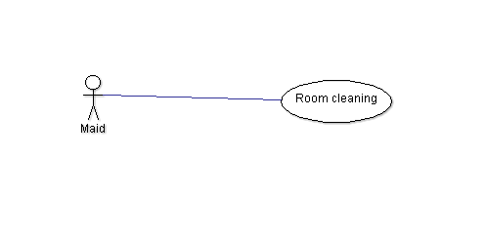

**4.2 Laundry Services**

4.2.1 **Description and Priority**

It is an essential part of house keeping. Wasing clothes and changing the

Bedsheets come under this.

4.2.2 **Stimulus/Response Sequences**

1. Maids have an acces to check the work allotted to them .

2. Accordingly the maids allotted slots for laundry services will handle these.

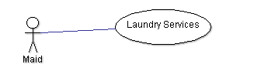

**4.3 Create Profile**

4.3.1 **Description and Priority**

This option provides the facility for updating the profiles of the users. This is

an optional feature.

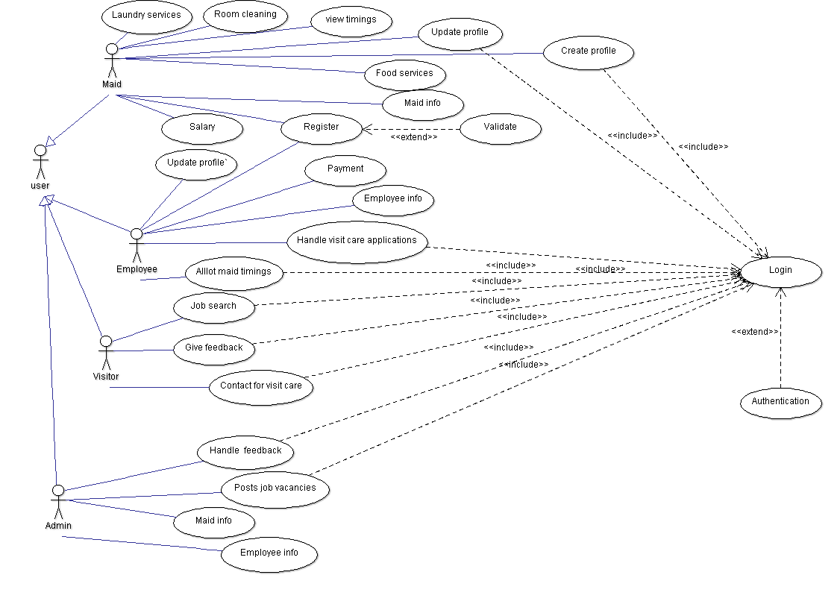

4.3.2 **Stimulus/Response Sequences**

The user who ever is interested in creating their own profile can access this

by clicking the create profile option. This is usually accessed by maids

and the Employees.

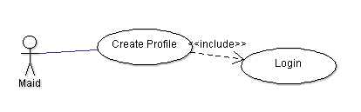

**4.4 Update profile**

4.4.1 **Description and Priority**

The user using this site can update their own profile that may be useful for

applying the job or can also be done by the persons already working in the

company. This is necessary for the people applying for the job.

4.4.2 **Stimulus/Response Sequences**

This option will be available only after a user creates his/her profile. If the

user wants to make any changes regarding his/her profile then will click on

update profile and then can make the necessary changes.

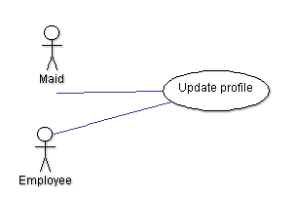

**4.5 Register**

4.5.1 **Description and Priority**

Register is different from login. Registration only happens the first time you

access the system.

4.5.2 **Stimulus/Response Sequences**

Once a user registers with the site he/she can access only a few features like

they can create their own profile.

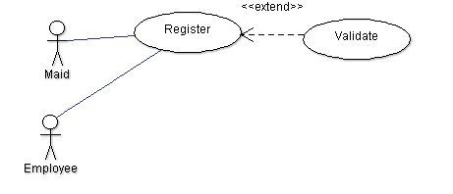

**4.6 Job Search**

4.6.1 **Description and Priority**

Through this feature any user can search for a job if required. This can be

accessed by visitors.

4.6.2 **Stimulus/Response Sequences**

1. The user logins into the site

2. If in need of a job they can see the vacancies available by clicking on jobs.

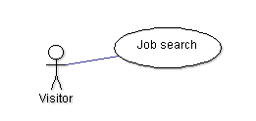

**4.7 Give Feedback**

4.7.1 **Description and Priority**

This is related to the work done by the maids. The customers are required to

give the feedback based on their performance. This is essential as it can bring

improvement in the work done by the maids. This feedback can also be given

by the visitors who contact the company for maids for their household work

based on a contract.

4.7.2 **Stimulus/Response Sequences**

1. The maid does the work that is allotted to her.

2. The customers give the feedback based on her performance.

3. If the work of the maid is not satisfactory she will need to improve herself in

that as per the feedback provided.

4. If the maid gets a good feedback there may be chances of her salary

increment.

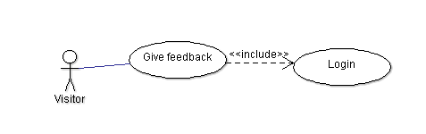

**4.8 Handle visit care applications**

4.8.1 **Description and Priority**

Visit care is the facility provided by the company through which people who are

busy and do not have the time to clean their house can appoint maids based on

contract for a minimum of 6 months. These applications are handled by the

employees.

4.8.2 **Stimulus/Response Sequences**

1. The person who is in need of a maid to clean the house will place an

application through the site.

2. The person must agree with the terms and conditions of the company.

3. The payment demanded by the company must be paid by the person.

4. If both agree to each others terms and conditions a contract is made . This

takes place between the employee and the customer.

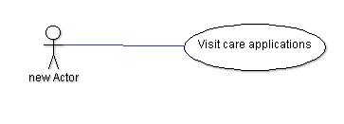

**4.9 Post job vacancies**

4.9.1 **Description and Priority**

If the company is need of maids then it advertises saying that there are

vacancies for the job of a maid.This is considered as less priority unless the

company is in very bad need of maids.

4.9.2 **Stimulus/Response Sequences**

1. If there is a need for maids the admin posts the job vacancies.

2. The visitors who are in search of job apply for it.

3. If they accept the terms and conditions of the compay they are given a job.

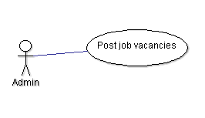

**4.10 Allot Maid timings**

4.10.1 **Description and Priority**

The whole work is divided between the maids as some of them are allotted

room cleaning some of them are allotted laundry services and some are

allotted food services. They are allotted specific timings for this. This has a

higher priority as it reduces clashes in the timings.It is done by employees.

4.10.2 **Stimulus/Response Sequences**

1. Maids are allotted a category of work.

2. They are allotted specific timings for doing that work.

3. These timings can be viewed by the maids and the work is done accordingly.

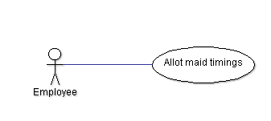

**4.11 Handle Feedback**

4.11.1 **Description and Priority**

The feedback given by the customers will be handled by the admin.

4.11.2 **Stimulus/Response Sequences**

1.Feedback is given by the customers

2. The admin can view all the feedbacks.

3. The maids are given the feedback they received so as to improve their

performance.

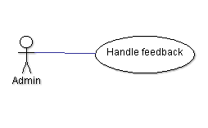

**4.12 Contact for visit care**

4.12.1 **Description and Priority**

The customers can contact the company if they need maids for their household

work through this facility.

4.12.2 **Stimulus/Response Sequences**

1. The customer fills the application accepting the terms and conditions.

2. A contract is made between the company and customer.

3. Maids are sent for work.

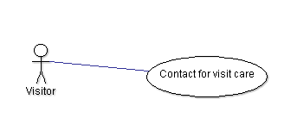

**4.13 Login**

4.13.1 **Description and Priority**

 Every time after your initial registration, you will log on to the system using

the username and password you created.

4.13.2 **Stimulus/Response Sequences**

Activities like creating profile, allot maid timings,job search etc require login.

This can be done with a username and password or can be done by usind mail.

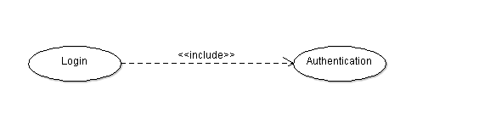

**4.14 Authentication**

4.14.1 **Description and Priority**

The process or action of verifying the identity of a user or process. This is an

Extension to login.

4.14.2 **Stimulus/Response Sequences**

Once the user logins then the username and password is verified if they are

correct. If they are correct he will be given access.



# Other Nonfunctional Requirements

## Performance Requirements

## The system is to perform at the same speed, co-operate in the same memory and require normalized disk utilization as that of a commercially available office productivity application software product. Currently these requirements range as such: 300 – 700 MHz CPU, 32 – 128 MB DRAM and .2 – 20 GB of permanent disk storageSafety Requirements.

## Security Requirements

There will be a separate login which can be accessed using either gmail or facebook.

This will be unique for every user..Until and unless these details are shared to anyone by the user there will be no issue.

## Software Quality Attributes

The Additional quality characteristics for the product that are important to either the customers or the developers are adaptability, availability, correctness, flexibility, interoperability, maintainability, portability, reliability, reusability, robustness, testability, and usability. By these qualities the usage of the product and as well as developing product will be easy.

## 5.3.1.Reliability

The system must provide all functionality whenever in use. System crashes are not to impair the data. System crashes are not to impair the system.

## 

## 5.3.2.Maintainability

The system is to be maintained entirely by the end user after delivery

**5.3.3.Portability**

It is made such that it can be used in operating systems other than the one in which it was created.I

## 5.3.4.Reusability

The system components must be reusable for the current and future versions of this product. Development reusability within the development organization is not necessary.

**5.3.5.Flexibility**

It is to be made such that it will adopt to any kind of changes in the future.

## 5.3.6. Resource Utilization

The system should be limited to the resources normally allocated to a commercially available PC application product

# 

# 6. Other Requirements

There are few requirements like database requirements etc.

Appendix A: Glossary

**company head** - Member of the Hospitality company , by whom the whole company works.

**Super manager**- Member of the Hospitality company who works as a company head Assistant.

**Python and Django Framework.**

**Functional Requirements -** A detailed list of all the services provided by the system.

**Customer -** A person who visits the Hospitality website for booking a home visit or download the brochure and various features.